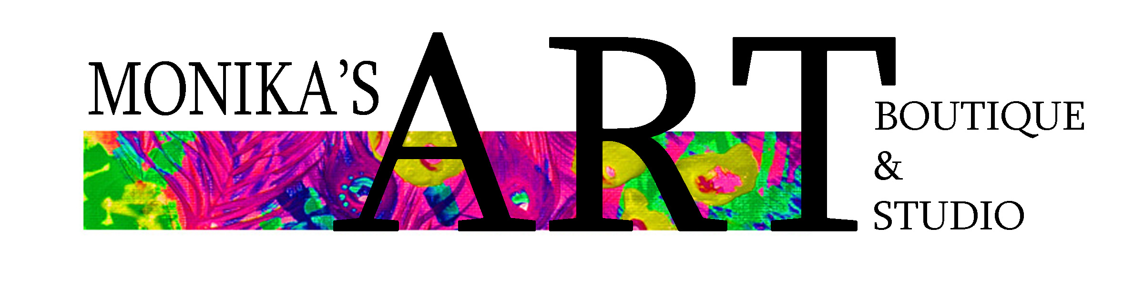
Social Media Marketing Package Platinum $1,500
Includes:
-3 posts a week on our Facebook, Instagram, Twitter
-2 ads in our newsletter per month
-3 Youtube Interviews & 1 Podcast Interview
-3 Facebook Live Interviews
-Your full collection listed on our website in our online store
-30 photos sent to you monthly of your work for your own use
-5 short videos monthly (for your own social media reels/videos)
-1 exhibit booth at Art World Expo 10th Anniversary Event (Date TBA)
-Online Auction participation: monthly online auction
-VendyArts: Showcase mini art or small work in the art vending machine
-1 show, demo or pop up at a retail partner location which we will set up for the vendor and help promote. Vendor will be responsible for setting up their own booth and bringing their work to the event/demo/or location.

Social Media Marketing Package Gold $1,000
Includes:
-2 posts a week on our Facebook, Instagram, Twitter
-1 ad in our newsletter per month
-2 Youtube Interviews
-2 Facebook Live Interviews
-20 photos sent to you monthly of your work for your own use
-2 short videos monthly (for your own social media reels/videos)
-Online Auction participation: monthly online auction

Social Media Marketing Package Silver $500
Includes:
-1 post a week on our Facebook, Instagram, Twitter
-1 ad in our newsletter per month
-1 Youtube Interview
-1 Facebook Live Interview
-10 photos sent to you monthly of your work for your own use
-2 short videos monthly (for your own social media reels/videos)

Social Media Marketing Package Bronze $250
Includes:
-1 post bi-weekly on our Facebook, Instagram, Twitter
-1 ad in our newsletter per month
-1 Youtube Interview
-5 photos sent to you monthly of your work for your own use
-1 short videos monthly (for your own social media reels/videos)

Why choose a package?
Our team can help your brand grow quickly and efficiently online in addition to your exhibit at our gallery. We work hard to sell in the gallery; yet there are millions of customers online searching for products just like yours that simply cannot come into the gallery in person! How can you reach those people?

Choosing a package will not only help us build your following, but will also help you gain valuable content for your own marketing strategies.

Our team is made up of professional artists, social media marketing experts, and retail partners who love to help businesses grow their brand, cross promote and achieve their goals. Choosing a package will help you make the most of your exhibit in our retail store and will help you reach new audiences which translates to new customers.

We strongly encourage vendors to participate in a monthly package as aggressive marketing helps your brand with views, new followers, and eventually new customers. A package will also offer you an accountability partnership and a team of dedicated professionals to help you with content that you can use for years to come. In addition to the content we create and send to you, all content that we post will be left on our sites indefinitely and you will be welcome to use all photos, videos, and content we share with you for life. A built in marketing team for a few dollars a day!

Email us at monikasartboutiquevendors@gmail.com
604 999 6177

Monika’s Art Boutique
MAB VENTURES INC.
Est. 2010

Studio:
3063 Lonsdale Avenue
North Vancouver, BC

Gallery:
934 Park Royal Mall South
West Vancouver, BC

